

Fontsize:40px Fontfamily: Fredoka One Color:white



Fontsize:30px Fontfamily: Fredoka One Color: #373737

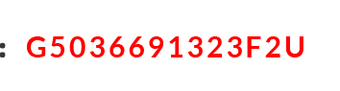

Fontsize:30px Fontfamily: Lato Color: # fe0000 Font weight: bold

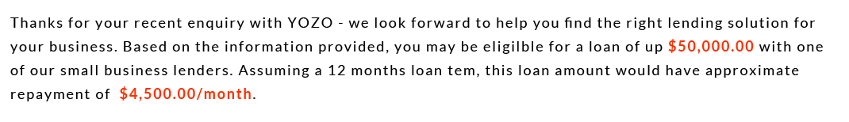

Fontsize:18px Fontfamily: Lato Color: # 010101

Red Part: Color: # fe3000 Font weight: bold



Fontsize:48px Fontfamily: Roboto Conden... Color: # 000000 Font weight: bold

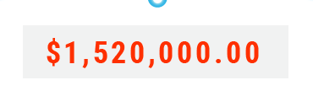

Fontsize:36px Fontfamily: Roboto Conden... Color: # fe3000 Font weight: bold

background: # f1f2f2

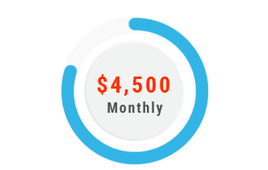

Price:

Fontsize:28px Fontfamily: Roboto Conden... Color: # fe3000 Font weight: bold

background: # f1f2f2

Monthly:

Fontsize:18px Fontfamily: Roboto Conden... Color: # 535456 Font weight: bold

Ring:

Background: background: # f1f2f2 # 32b5e5



Fontsize:36px Fontfamily: Lato Font weight: bold



Fontsize:24px Fontfamily: Lato Font weight: bold Color:# 1e1e1e

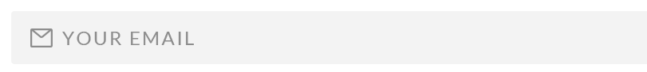

Fontsize:24px Fontfamily: Lato Font weight: bold Color:# 8d8d8d Background: # f3f3f3

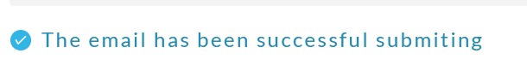

Fontsize:24px Fontfamily: Lato Color:# 248bb1

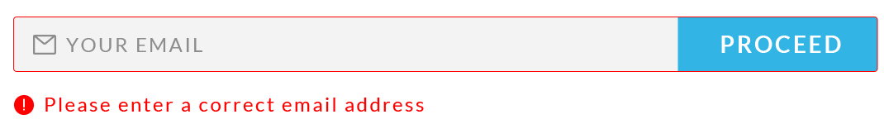

Fontsize:24px Fontfamily: Lato Color:# fe0000